**Laser Project**

**Solder Fume Extractor**

**Prepared for Bainbridge BARN, ETA Studio - bainbridgebarn.org**

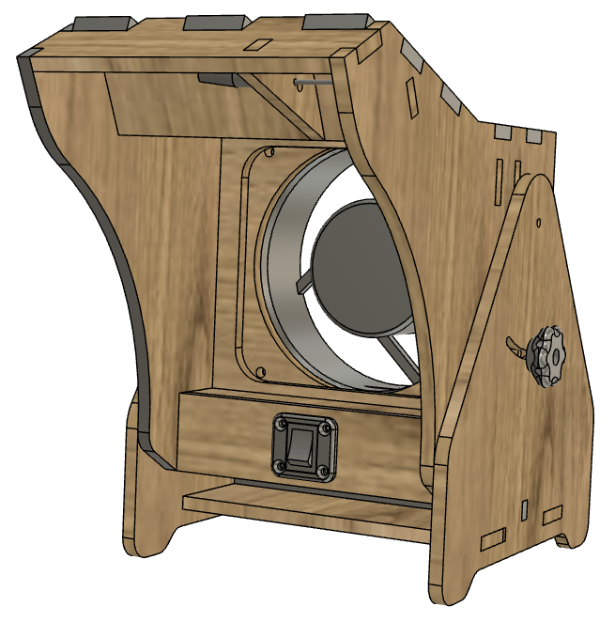

# Overview

In this project, you will make a benchtop solder fume extractor. This fume extractor features adjustable tilt, a high-output LED work-light and replaceable carbon filter. You'll cut out the parts for the base and housing on the laser, assemble the wiring, print some 3D parts, then glue and screw it all together.

# Material required

* 2 sheets 300 x 500 3.2mm thick MDF or Plywood
* Laser fume extractor parts kit from ETA
* White glue

# Difficulty level

This project difficulty level is: MEDIUM. You'll practice the laser skills, 3D printer skills and soldering skills. The instructions assume you have beginner level skills in these areas.

|  |
| --- |
| **Safety First**   1. **Always follow the safety procedures you learned in the laser class.** 2. **Steps for using the laser are posted. Follow them.** 3. **We were all beginners once. If you have a question, ask a monitor for help.** 4. **Never try to run the laser with the lid open.** |

OK, Let's get started…

**TASK 1 - Get prepared**

|  |  |  |
| --- | --- | --- |
| **1** | Get two pieces of material that are 300mm x 500mm and 3.2mm (1/8") thick. These can be purchased from the ETA studio material stock cupboard. MDF is recommended, but plywood will also work. | Ask the studio monitor for assistance purchasing the material. |
| **2** | Verify your material thickness using calipers. They are located in the toolbox, usually the bottom drawer. |  |
| **3** | Get the zip file for this project . The files are located on all of the workstations in a desktop folder called "ETA-PROJECTS", and the zip file is called "solder fume extractor V1.zip" | The official repository for these in in the BARN github repository : |
| **4** | The files in the zip archive are:  Laser fume extractor instructions.pdf  LB (LightBurn files)  Laser fume extractor – sheet 1.lbrn  Laser fume extractor – sheet 2.lbrn  STL (3D files for printed parts)  Fan guard nut keeper - need 4.stl  Nut keeper for knob.stl  Nut keeper for pivot – need 2.stl  Switch mount.stl  Tightener knob.stl |  |

**TASK 2 - Cutting and Engraving the first sheet**

|  |  |  |  |
| --- | --- | --- | --- |
| **1** | Pick a Laser to use. Either Little Blue or Big Red can be used. These instructions were made using Little Blue |  | |
| **2** | Log into the computer (password is "maker") and start LightBurn by selecting its desktop icon. |  | |
| **3** | Open the first file - "Laser fume extractor – sheet 1.lbrn ". If you are cutting on Little Blue, it should look like the picture on the right.  On Big Red, the design will be mirrored. – don't worry, it's easy to fix, you just select everything in the drawing then select the right/left mirror button. (This is a fact of life we have to face with Little Blue and Big Red. One is right-handed and the other left handed. Sometimes the image needs to be switched.) | Mirror | |
| **4** | Check that the cutting parameters for etching and cutting are what you want. This design was made with three layers:  Reference - This layer is for things that are not cut or etched. A place for notes about the design.  Etch – Most parts have their name on them (where they will not show after assembled) and also some labeled slots or tabs to help in assembly. You can choose to turn off output for this layer if you want.  cut through – The lines to cut out the parts. | Time | |
| **5** | Check optimization settings.  In LightBurns Laser window, check that the Optimize Cut Path switch is on (green), then select the Optimization Settings button.  Check that the following switches are are both on (green).    Cut inner shapes first – This will cut the holes in the center of each part before the outline is cut.  Remove overlapping lines – The tells the laser to not cut lines twice where two parts are positioned so that they share an edge. |  | |
| **6** | Follow the posted studio procedure for turning on the laser, checking the chiller and air pump, and turning on the ventilation fans. | See the studio monitor if you want a quick refresher on the procedure. |
| **7** | Put your material in the laser, move the nozzle to the middle of the material using the control panel buttons, and "Focus" the laser. This really means raising or lowering the bed so that the laser is the right distance from the laser nozzle.  On Little Blue, place the "focusing billet" (two sheets of 3.2mm material stacked together) on top of your material and under the laser nozzle. Look for the knob on the front-right inside the laser. Twist it to raise and lower the bed. Adjust it until the nozzle is just about touching the focusing billet. You'll hear the sound of the air exiting the nozzle change as you get to the right place. Remove the focusing billet.  On Big Red, see the studio monitor for assistance focusing on your material. | E:\Mike\BARN\Laser\project - 125 poker chips\pictures\P1000902 - SMALL.JPG  Focusing knob  *Focusing should always be done before positioning the laser's origin.* |
| **8** | Use the front panel controls to move the red-dot to the back-left corner of the material, about a few mm from the corner.  On the laser's control panel, press the "origin button". *This tell the laser to remember this position as the place to start when cutting"*  If it looks like the red dot is not under the laser nozzle, it might have been bumped and moved. Ask the monitor for assistance repositioning it. *The red-dot is just an indicator, not the cutting laser (which is not visible to the human eye).* | E:\Mike\BARN\Laser\project - 125 poker chips\pictures\P1000901 -small.JPG |
| **9** | Look on the right side of the LightBurn window to find the "Laser Window". Check that the "Start From" is set to "User Origin", and that the Job Origin is set to the upper left corner.  ***Start from: User origin*** *tells the laser to aligh the job form the origin set on the laser's control panel.*  ***Job Origin*** *Tells the laser which part of your design should be lined up with the origin set on the laser. The little green square on lightburn is what will be located at the laser's origin.* | Start From  Job Origin |
| **10** | Select the Send button in LightBurn's Laser window to copy your file to the laser.  *This allows you to do the rest of the work from the laser itself.* | Send |
| **11** | Find the "Frame" button on the laser control panel and press it. Watch the red dot travel around the outside of the planned cuts. If the red dot goes off the edge of the material, you need to adjust the position of the material in the laser and hit frame again. Repeat until the red dot stays on the material. | If you didn’t get your user origin set properly, the laser may "go somewhere" other than your origin before following the frame path. If this happens, you may need to reposition the laser and set the user origin again. |
| **12** | Close the door of the laser and select on the "Start" button on the Laser's control panel. The laser will etch your parts and then cut them out. |  |
| **13** | Open the laser and take out all your chips and toss the waste in a garbage can. |  |

**TASK 3 - Cutting and engraving the second sheet**

|  |  |  |
| --- | --- | --- |
| **1** | Open the "Laser fume extractor – sheet 2.lbrn " file. It should look like the image on the right. Again, you might need to mirror the image if you are cutting on Big Red. See Task 2, Step 3 if you need a refresher. |  |
| **2** | Follow the same steps you did for the first sheet (Task 2), and you'll have all your laser cut parts. |  |

**TASK 4 – 3D print the printed parts**

|  |  |  |
| --- | --- | --- |
| **1** | This project uses several 3D printed parts that you'll need to make. The recommended material is PLA, but other materials should also work. The parts are listed below.  STL (3D files for printed parts) |  |
|  | Fan guard nut keeper - need 4.stl  You will need 4 of these parts. | They are used to hold the nuts for the screws that hold in the fan. You could assemble the project without these, but it'll be tricky to hond the nuts while you get the screws started. |
|  | Nut keeper for knob.stl  You will need one of these parts | This part holds the nut that the knob willscrew into to hold the desired tilt of the fume extractor. |
|  | Nut keeper for pivot – need 2.stl  You will need 2 of these parts | These parts form the axle that the housing rotates on. |
|  | Switch mount.stl  You will need one of these parts | This parts holds the switch securely to the front of the housing and make it so you can disassemble the witing if you even need to. |
|  | Tightener knob.stl | This is the know that's used to tighten lock in the desired tilt of the housing. |

**TASK 5 - Assemble the wiring**

|  |  |  |
| --- | --- | --- |
| **1** |  |  |

**TASK 4 - Assemble the box**

|  |  |  |
| --- | --- | --- |
| **1** | Fit test - We'll use white glue to glue the box part together, but it's best to "dry-fit" the parts together to see if there are any tight fits that need to be trimmed slightly. Follow the steps below, without glue, then take it apart and apply the glue as you assemble it again. The pictures show the recommended glue locations/ |  |
| **2** | Put spacers in the bottom of the box.  You can use glue on these or skip it, since the spaces are completely captured by the sides. I recommend glue because it makes the finished box stronger. C:\Users\ms\AppData\Local\Microsoft\Windows\INetCache\Content.Word\Box assy 1.jpg |  |
| **3** | Put the first side on – both sides are identical, but will slip together more easily if the side that was "up in the laser is on the inside of the box.  Add glue to the top edges of the bottom and spacers and stick on one of the sides. You'll need to move the spaces a bit to get them to align with the holes in the sides. | P1000862  C:\Users\ms\AppData\Local\Microsoft\Windows\INetCache\Content.Word\Box assy 4.jpg |
| **4** | Glue on one end. I recommend putting glue on the surfaces of the main piece, not the piece you are adding. It's less mess that way. | E:\Mike\BARN\Laser\project - 125 poker chips\pictures\Box assy 5.JPG  C:\Users\ms\AppData\Local\Microsoft\Windows\INetCache\Content.Word\P1000865.jpg |
| **5** | Glue on the other end the same way. | C:\Users\ms\AppData\Local\Microsoft\Windows\INetCache\Content.Word\P1000866.jpg |
| **6** | Finally glue on the last side. This is the trickiest side to get on because of the need to align all the tabs. But your dry-fit give you practice.  Set this assembly aside and wait for the glue to dry. | C:\Users\ms\AppData\Local\Microsoft\Windows\INetCache\Content.Word\P1000867.jpgC:\Users\ms\AppData\Local\Microsoft\Windows\INetCache\Content.Word\P1000868.jpg |

That's it, you're all done. We hope you've enjoyed the experience and sharpened your LightBurn and laser cutter skills in the process.